

**Faculty:**  Business Administration and Commerce

**Department:** Management Information System

**“Charity web application”**

**Project Members:**

Anan Abdelhamid 20170451

Laila Ahmed 20173558

Mahmoud Ashraf 20173179

Nada Sameh 20172966

Sohaila Mahmoud 20173082

**Supervised By:** Dr. Ahmed Sayed

Table of Contents

List of Figures 5

List of Tables 6

Chapter One 7

Introduction (Project Proposal) 7

1.1 Introduction 8

1.2 The Problem 8

1.3 The Purpose and Target Users 8

1.4 Web application Functions/Features 9

1.5 Tools of Implementation 13

1.6 System Requirements 14

1.7 Software Model (Development Methodology) 15

1.8 Plan of Work 16

Chapter Two 19

(Project Planning) 19

2.1 Introduction 20

2.2 Benefits of project management 20

2.3 Project planning techniques 21

2.4 Common available planning software: 21

2.5 Planning Techniques 23

2.5.1 Task Table 23

2.5.2 Gantt Chart 25

2.5.3 Risk Management 26

Chapter Three 28

(Feasibility Study) 28

3.1 Introduction 29

3.2 Feasibility Study 29

3.2.1 Feasibility study types: 29

3.2.2 Importance of Feasibility Study 30

3.2.3 Technical feasibility 31

3.2.4 Project Financial Costs 32

3.2.5 Revenue model Definition 33

3.2.6 Payback Period 34

3.2.7 Cash Flow 35

3.2.8 Operational Feasibility 37

3.2.9 User interface and attraction 38

3.2.10 Support System 38

Chapter Four 39

(System Analysis and Design) 39

4.1 Introduction 40

4.1.1 Comparison between Structured approach and Object-oriented approach 41

4.2 Data Flow Diagram 42

4.3 Level Zero Data Flow Diagram 43

4.4 Process Logic Description 44

4.4.1 Structured English 44

4.5 Data Dictionary 53

4.5.1 Data element 54

4.5.2 Data flow 55

4.5.3 Data Store 56

4.5.4 Data process 57

4.5.5 External entity 58

4.6 Use Case Diagram 59

4.6.1 UML Use Case Description 60

(System Design) 61

5.1 introduction 62

5.2 Entity Relationship Diagram 63

5.3 Class diagram 64

Summary 66

References 68

# List of Figures

Figure 1: Waterfall Model 14

Figure 2: Gantt Chart 24

Figure 3: Data Flow Diagram 41

Figure 4: Level Zero Diagram 42

Figure 5: Use Case Diagram 58

Figure 6: Entity Relationship Diagram 62

Figure 7: Class Diagram 64

# List of Tables

Table 1: Task Table 24

Table 2: Risk Identification & Risk Analysis 26

Table 3: Risk Analysis 27

Table 4: Financial Costs 32

Table 5: Payback Period 34

Table 6: Cash Flow (Year One) 36

Table 7: Cash Flow (Year Two) 36

Table 8: Use Case Description 60

# Chapter One

# Introduction (Project Proposal)

# Introduction

Helping others gives us a new perspective to life and keeps us from focusing on our own problems. Besides helping others, doing a good deed warms our own hearts and makes us feel good. By focusing more on others rather than ourselves, this is a reminder for the many people out there who are in more need for help than we are. Thus, charities offer individuals the opportunity to provide help to those who are in need. Mobile Web Applications present an easy way of reaching out to charities, thus this is this project’s topic. The act of charity itself is a social activity for those who may feel isolated and alone, it helps them be able to feel like they are contributing to the overall well-being of their communities. Most of the charities are included, whether they are known or unknown, big or small.

# The Problem

The Egyptian charity community lacks in the aspect of online availability to the Egyptian population.

In order for individuals to participate with charities, they have to reach out to them through calls, as there are no other methods of communication. Therefore, a charity web application will elevate the process of doing good deeds, as it will constantly allow Egyptians the opportunity of donating to the less fortunate due to the ease of access.

# The Purpose and Target Users

The main purpose of a charity web application is for individuals to be able to donate whatever they can with a touch of a button from the comfort of their homes. In addition, it provides social benefits to the public, in the form of the relief of assisting people at times of need, especially those who are the victims of natural disasters, catastrophes, hunger, diseases or poverty. The application will supply the less fortunate with food, medical aid and other fundamental needs.

The target users are the able ones, who have smartphones and/or laptops or personal computers (any smart devices that have an access to the internet) and are able to donate and/or want to donate stuff for the well-being of the Egyptian community.

# Web application Functions/Features

**Admin:**

* **Access Database:** the admin will have access to the Database including all the registered donors and charities’ information. The admin will be able to view, organize and sort out the records in the Database according to the needs required by the system.
* **Accept/Reject subscription requests:** once a charity has subscribed and their account has been set up, the admin has the authority to accept their subscription in order to for a charity Database. Moreover, if a charity did not follow the required steps to set an account up, or turned out to be an illegitimate charity, the admin will have the authority to reject their request to be a part of the system.
* **Track transactions:** the admin will be able to track all the ongoing/pending transactions, and add or remove transactions.
* **Remove accounts:** the admin will have the ability to remove any account or charity from the Database, if the intended account or charity was proven to be unsanctioned or followed any unlawful actions.
* **Edit system/maintenance:** the ability to add or remove any of the donation categories, depending on the required needs of the system, as well as any necessary changes for the entire system.

**Charity:**

* **Subscribe to website:**  for a charity to sign up and have an account set up of for them, they have to pay a yearly subscription fee of 4000 LE.
* **Receive accept/reject email from system:**  once a charity has subscribed and set up an account for them, they will receive an email confirming their acceptance, or an email with rejection, the rejection reason, and what needs to be done correctly for the specified charity to be accepted into the system.
* **Give Feedback:** for charities to write their opinions and their rating regarding our system and procedures.
* **Integrate/Link social media:** charities will have the option to link their [social media](https://www.appypie.com/social-network-app-builder) profiles to motivate other people to make donations and spread our name.

**Donor:**

* **Give Feedback:** For donors to write their opinions and their rating regarding our system and procedures.
* **Sign up:** donor creates an account, filling in a form with their personal details. This account will be reflected in the system’s Database.
* **Donate/Login:** once a donor is signed in, they will navigate through the website, choose their category for donation and charity of choice, and then submit their donation details online.
* **Pay with:** back account or direct deposit.
* **Receive confirmation email:** an email will all the details of the donation, amount, chosen charity and pickup address, to confirm that the donation has been approved and the previous information has the correct details.
* **Chose a help seeker:** there will be a list of all the help seekers who have signed up to the website to receive aid from the donors, which in return will allow the donor to view this list, and choose from amongst this list the specified individual they wish to help by sending donations to.

**System:**

* **Display:** The web application will show a detailed overview of all the charitable categories, which are; clothes, food, and money donation, books, school supplies, medical supplies as well as home supplies. With the help of these categories, the users would pick the desired category so specify which items they wish to donate.
* **Show Historical Data:** The web application will be rich with historical data and information about all the charities available through our application.
* **List transactions:** once the admin requests to track any transaction, the system will display the intended transaction for the admin.
* **Validate subscription:** once a charity has signed up, the system will ask the charity to confirm whether they are certain they want to proceed with the process, including paying the subscription fee, as once they have clicked “confirm”, then filled in their details, followed by their subscription request has been accepted by the admin, money will be withdrawn from their bank account.
* **Send email:** email sent to donor to notify them and confirm the donation details, including payment details, intended charity’s details, and confirming the pickup address of the donor.
* **Rate/Review charity:** each charity will have a rating scale, based on the donors of the website, to determine their authenticity.
* **Send accept/reject SMS to help seeker:** an SMS will be sent to the individual who is seeking help, confirming whether their sign up has been accepted or rejected based on the information this individual has provided in their profile.

**Help Seeker:**

* **Sign up:** an individual who is seeking help creates an account, filling in a form with their personal details, this includes the reason they need help, average income per month as well as their location. This account will be reflected in the system’s Database.
* **Receive confirmation SMS**: once an individual who’s seeking help has signed up, they will receive a confirmation SMS from the system, specifying whether their request to sign up has been rejected or accepted.
* **Receive donation SMS**: once a donor has chooses an individual who is seeking help to offer them with a donation to aide their request, this individual who is seeking help will receive an SMS with the details of the donor as well as details of the donation offered to them.

# Tools of Implementation

* Languages used

Server-Side

* PHP: is mainly focused on server-side scripting, which allows the use of techniques used in other CGI programs can do, such as collect form data, generate dynamic page content, or send and receive cookies.[1]
* MySQL: is a freely available open source Relational Database Management System (RDBMS) that uses Structured Query Language (**SQL**).[2]

Client-Side

* HTML: stands for Hyper Text Markup Language, HTML is the standard markup language for creating Web pages, HTML describes the structure of a Web page, HTML consists of a series of elements, and HTML elements tell the browser how to display the content.[3]
* JavaScript: is a scripting language that enables you to create dynamically updating content, control multimedia, animate images, and pretty much everything else.[4]
* CSS: is a language of style rules that we use to apply styling to our HTML content, for example setting background colors and fonts, and laying out our content in multiple columns.[5]
* Materials
* We use our own computers for developing the software.
* User will use mobile, tablet or pc connected to the internet.
* Programs used:
* Microsoft Project: (MSP) is a project management software made for project managers so they can control their projects. Depending on your plan, Microsoft Project lets you plan projects, assign tasks, manage resources, and make reports and more. It offers a full plate of services and was quick to dominate the project management software field when it was first introduced [6]
* WAMP Server: is a software stack, which means installing WAMP installs Apache, MySQL, and PHP on your operating system. Even though you can install them separately, they are usually bundled up, and for a good reason too. Visual Studio Code: Used as the main text editor.[7]

# System Requirements

* **Hardware:**

**For Development**

* + **Personal Computer**
    - 3.8 – 4.2 GHz Processor
    - 16GB Ram
  + **Host Server**

**Minimum Requirements for Users**

* + **Laptops, Personal Computer, Tablets and Mobile Phones**
    - Internet Access
* **Software:**

**For Development**

* + MS project
  + MS office
  + Visual studio code
  + Dreamweaver
  + WAMP Server

**For users**

* + - Windows 7 Pro or newer
    - MacOS
    - Linux OS

# Software Model (Development Methodology) [8]

Figure : Waterfall Model

The Software Model used is the “Waterfall Model”. The Waterfall Model is also known as the linear-sequential life cycle model because it is quite simple to understand and use. In the Waterfall Model, each phase must be completed, in its specified meaner, before the next phase can begin. Also, phases cannot overlap each other.

The Waterfall Model allows for full control over the processes required for a project to be completed, as well as dividing the departments into sections, where each phase required is clearer to follow through. The help of the schedules makes sure that each stage of development is completed on its specified time and manner. The steps of the Waterfall Model goes as the following: concept development followed by design, implementation, testing, installation, troubleshooting, and ends finally at operation and maintenance. Each phase of development proceeds in strict order, and as mentioned above, the current phase must be completed before the next one starts.

The Waterfall Model is simple and easy to understand and use, as well as containing clearly defined stages along with easily understood milestones. Also, it arranges tasks and the processes and results are well documented.

# Plan of Work

The plan of work shows the outline of the set of goals and processes needed to be accomplished. It also offers the reader a better understanding of the scope of the project, as well as help to stay organized whilst working on the project, by breaking down the main processes into smaller achievable tasks. This project’s plan of work goes as the following:

1. Chapter two covers a very crucial topic that is Feasibility Study. This is a Cost-Benefit analysis where the analyst sums the benefits of a situation or action and then subtracts the costs associated with taking that action in order to undertake the best decision that will benefit the project as a whole.
2. Chapter Three. This chapter covers Project Planning, which is a layout of each task required, alongside the duration of each task plus who is responsible for each of those tasks to be completed. It is divided as the following:

→ Task Table, providing a series of standard fields used on each of the tables that extend it, such as the Incident and Problem tables.

→ Activity Chart, showing the operations or tasks that make up a process, plotted against time.

→ Staff Allocation Chart, which provides an easy way of creating a list of the project’s resources and assigning the right human resource, as well as the necessary material, or equipment to be used to achieve intended goals.

1. Chapter Four covers the topic System Analysis with its Structured and Object Oriented Techniques. The Structured techniques include:

→ Data Flow Diagram.

→ Data Dictionary.

→ Process Logic Description.

▪ Decision Trees

▪ Decision Tables

▪ Structured English

The Object Oriented Techniques include:

→ Use Case Diagrams

→ Objects List

→ Class Diagram

1. Chapter Five talks about System Design, System Design has Structured and object Oriented Techniques such as the following:

→ Structure Chart

→ Logical DB Design (Entity Relationship Diagram (After Applying Normalization))

→ CRUD Matrix

→ Detailed Class Diagram

→ Site Map

→ Screen Designs

→ Reports Designs

1. Chapter Six is the Implementation phase which includes a detailed explanation of:

→ Used Tools Overview.

→ Samples of implemented screens, queries results, site pages and Reports.

→ Testing Examples and System Results

1. Lastly, Chapter seven, as how any project comes to an end with Conclusions and Recommendations regarding the charity website. Following the Conclusion and Recommendations chapter, a References Appendix A of code Samples print out, such as Programs and Queries will be included.

# Chapter Two

# (Project Planning)

# Introduction

Project management: is a powerful business tool that can deliver many advantages to businesses of all sizes. It gives you repeatable processes, guidelines and techniques to help you manage the people and the work involved in your projects. It can increase your chances of success and help you deliver projects consistently, efficiently, on time and budget.

# 2.2 Benefits of project management [9]

The main advantage of project management is that is helps you to manage your projects effectively, enabling you to resolve problems more quickly.

It takes time and money to manage a project, however following good practices can help you to

* improve your chances of achieving the desired result
* gain a fresh perspective on your project, and how it fits with your business strategy
* priorities your business' resources and ensure their efficient use
* set the scope, schedule and budget accurately from the start
* stay on schedule and keep costs and resources to budget
* improve productivity and quality of work
* encourage consistent communications amongst staff, suppliers and clients
* satisfy the various needs of the project's stakeholders
* mitigate risks of a project failing
* increase customer satisfaction

# 2.3 Project planning techniques[10]

Project management techniques make managing projects easier and more effective. They can be applied to any project, regardless of the field or industry. And used in tandem with project management software, they help save time and reduce costs.

There are many project management techniques to choose from, including the following:

* work breakdown structure (WBS)
* Gantt chart
* pert diagram
* critical path method

In the following project, both of Gantt chart and pert diagram to management, scheduling our project and to time estimates to get a project complete on time.

# 2.4 Common available planning software: [11]

A project management application is used in many different small and large-sized firms.

Using project planning tools makes it easy to schedule the allocation of resources. Project managers use work planning tools for ensuring optimal allocation of resources within a specific timeline.

🡪MS Project

🡪ProofHub

🡪WorkZone

For starters, it specifies how and when each task should be completed. Then, these tasks are assigned to various team members and allocated any necessary resources. This makes the entire process smooth and transparent, with everyone aware of their duties and responsibilities. This is precisely what Microsoft Project is good at. It utilizes the following to ensure accurate project management:

• Prioritization: Helps you prioritize your project’s tasks, eliminating surprises and allowing your team to focus on addressing the most important matters first.

• Task management: Allows project managers to define the activities involved in the project and decide how they should be assigned to different members.

• Team calendar: Having a shared team calendar is a real blessing, as it ensures that all team members are on the same page at all times. Your team members will get notifications for upcoming meetings and events and be able to synchronize their work schedules for more efficient workflow.

And have a really valued benefits and features such as:

* Project Timeline View
* Collaboration
* Reporting
* Resource Management
* Multiple Projects

# Planning Techniques

## 2.5.1 Task Table

The Task Table provides a series of standard fields used on each of the tables that extend it, including the incidents and their milestones.

The following is the Charity Web Application’s Task Table:

|  |  |  |  |  |  |  |  |  |  |  |  |  |  |  |  |  |  |  |  |  |  |  |  |  |  |  |  |  |  |  |  |  |  |  |  |  |  |  |  |  |  |  |  |  |  |  |  |  |  |  |  |  |  |  |  |  |  |  |  |  |  |  |  |  |  |  |  |  |  |  |  |  |  |  |  |  |  |  |  |  |  |  |  |  |  |  |  |  |  |  |  |  |  |  |  |  |  |  |  |  |  |  |  |  |  |  |  |  |  |  |  |  |  |  |  |  |  |  |  |  |  |  |  |  |  |  |  |  |  |  |  |  |  |  |  |  |  |  |  |  |  |  |  |  |  |  |  |  |  |  |  |  |  |  |  |  |  |  |  |  |  |  |  |  |  |  |  |  |  |  |  |  |  |  |  |  |  |  |  |  |  |  |  |  |  |  |  |  |  |  |  |  |  |  |  |  |  |  |  |  |  |  |  |  |  |  |  |  |  |  |  |  |  |  |  |  |  |  |  |  |  |  |  |  |  |  |  |  |  |  |  |  |  |  |  |  |  |  |  |  |  |  |  |  |  |  |  |  |  |  |  |  |  |  |  |  |
| --- | --- | --- | --- | --- | --- | --- | --- | --- | --- | --- | --- | --- | --- | --- | --- | --- | --- | --- | --- | --- | --- | --- | --- | --- | --- | --- | --- | --- | --- | --- | --- | --- | --- | --- | --- | --- | --- | --- | --- | --- | --- | --- | --- | --- | --- | --- | --- | --- | --- | --- | --- | --- | --- | --- | --- | --- | --- | --- | --- | --- | --- | --- | --- | --- | --- | --- | --- | --- | --- | --- | --- | --- | --- | --- | --- | --- | --- | --- | --- | --- | --- | --- | --- | --- | --- | --- | --- | --- | --- | --- | --- | --- | --- | --- | --- | --- | --- | --- | --- | --- | --- | --- | --- | --- | --- | --- | --- | --- | --- | --- | --- | --- | --- | --- | --- | --- | --- | --- | --- | --- | --- | --- | --- | --- | --- | --- | --- | --- | --- | --- | --- | --- | --- | --- | --- | --- | --- | --- | --- | --- | --- | --- | --- | --- | --- | --- | --- | --- | --- | --- | --- | --- | --- | --- | --- | --- | --- | --- | --- | --- | --- | --- | --- | --- | --- | --- | --- | --- | --- | --- | --- | --- | --- | --- | --- | --- | --- | --- | --- | --- | --- | --- | --- | --- | --- | --- | --- | --- | --- | --- | --- | --- | --- | --- | --- | --- | --- | --- | --- | --- | --- | --- | --- | --- | --- | --- | --- | --- | --- | --- | --- | --- | --- | --- | --- | --- | --- | --- | --- | --- | --- | --- | --- | --- | --- | --- | --- | --- | --- | --- | --- | --- | --- | --- | --- | --- | --- | --- | --- | --- | --- | --- | --- | --- | --- | --- | --- | --- | --- | --- | --- | --- | --- | --- | --- | --- |
| |  |  |  |  |  |  | | --- | --- | --- | --- | --- | --- | | ID | Name | Duration | Start | Finish | Predecessors | | 1 | **Project** | **197 days** | **21 October 2020 08:00 AM** | **05 May 2021 05:00 PM** |  | | 2 | Project Proposal | 14 days | 21 October 2020 08:00 AM | 03 November 2020 05:00 PM | | | 3 | **Project Proposal Delivery** | **0 days** | **03 November 2020 05:00 PM** | **03 November 2020 05:00 PM** | **2** | | 4 | **Project Planning** | **8 days** | **04 November 2020 08:00 AM** | **11 November 2020 05:00 PM** | | | 5 | Task Table | 2 days | 04 November 2020 08:00 AM | 05 November 2020 05:00 PM | 2 | | 6 | Activity Chart | 3 days | 06 November 2020 08:00 AM | 08 November 2020 05:00 PM | 5 | | 7 | Staff Allocation Chart | 3 days | 09 November 2020 08:00 AM | 11 November 2020 05:00 PM | 6 | | 8 | **Project Plan Delivery** | **0 days** | **11 November 2020 05:00 PM** | **11 November 2020 05:00 PM** | **4** | | 9 | **Feasibility Study** | **14 days** | **06 November 2020 08:00 AM** | **19 November 2020 05:00 PM** | **5** | | 10 | **Feasibility Study Delivery** | **0 days** | **19 November 2020 05:00 PM** | **19 November 2020 05:00 PM** | **9** | | 11 | **System Analysis Phase** | **28 days** | **20 November 2020 08:00 AM** | **17 December 2020 05:00 PM** | | | 12 | Data Flow Diagram | 5 days | 20 November 2020 08:00 AM | 24 November 2020 05:00 PM | 9 | | 13 | Data Dictionary | 4 days | 25 November 2020 08:00 AM | 28 November 2020 05:00 PM | 12 | | 14 | **Process Logic Description** | **4 days** | **29 November 2020 08:00 AM** | **02 December 2020 05:00 PM** | | | 15 | Decision Trees | 4 days | 29 November 2020 08:00 AM | 02 December 2020 05:00 PM | 13 | | 16 | Decision Tables | 4 days | 29 November 2020 08:00 AM | 02 December 2020 05:00 PM | 13 | | 17 | Structured English | 4 days | 29 November 2020 08:00 AM | 02 December 2020 05:00 PM | 13 | | 18 | Use Case Diagrams | 5 days | 03 December 2020 08:00 AM | 07 December 2020 05:00 PM | 14 | | 19 | Object List | 5 days | 08 December 2020 08:00 AM | 12 December 2020 05:00 PM | 18 | | 20 | Class Diagram | 5 days | 13 December 2020 08:00 AM | 17 December 2020 05:00 PM | 19 | | 21 | **System Analysis Report Delivery** | **0 days** | **17 December 2020 05:00 PM** | **17 December 2020 05:00 PM** | **11** | | 22 | **System Design** | **48 days** | **18 December 2020 08:00 AM** | **03 February 2021 05:00 PM** | | | 23 | Structure Chart | 12 days | 18 December 2020 08:00 AM | 29 December 2020 05:00 PM | 20 | | 24 | Logical DB Design | 12 days | 18 December 2020 08:00 AM | 29 December 2020 05:00 PM | 20 | | 25 | CRUD Matrix | 12 days | 30 December 2020 08:00 AM | 10 January 2021 05:00 PM | 24 | | 26 | Detailed Class Diagram | 12 days | 11 January 2021 08:00 AM | 22 January 2021 05:00 PM | 25 | | 27 | Site Map | 12 days | 23 January 2021 08:00 AM | 03 February 2021 05:00 PM | 26 | | 28 | Screen Designs | 12 days | 23 January 2021 08:00 AM | 03 February 2021 05:00 PM | 26 | | 29 | Report Designs | 12 days | 23 January 2021 08:00 AM | 03 February 2021 05:00 PM | 26 | | 30 | **System Design Delivery** | **0 days** | **03 February 2021 05:00 PM** | **03 February 2021 05:00 PM** | **22** | | 31 | **Implementation** | **63 days** | **04 February 2021 08:00 AM** | **07 April 2021 05:00 PM** |  | | 32 | Database | 20 days | 04 February 2021 08:00 AM | 23 February 2021 05:00 PM | 22 | | 33 | User Interface | 20 days | 04 February 2021 08:00 AM | 23 February 2021 05:00 PM | 22 | | 34 | Programs | 29 days | 24 February 2021 08:00 AM | 24 March 2021 05:00 PM | 32 | | 35 | Integration | 14 days | 25 March 2021 08:00 AM | 07 April 2021 05:00 PM | 34 | | 36 | **Implementation Report Delivery** | **0 days** | **07 April 2021 05:00 PM** | **07 April 2021 05:00 PM** | **31** | | 37 | **Validation & Verification** | **7 days** | **08 April 2021 08:00 AM** | **14 April 2021 05:00 PM** | **31** | | 38 | **Installation** | **7 days** | **15 April 2021 08:00 AM** | **21 April 2021 05:00 PM** | **37** | | 39 | **Review** | **7 days** | **22 April 2021 08:00 AM** | **28 April 2021 05:00 PM** | **38** | | 40 | **Finalizing Documentation** | **7 days** | **29 April 2021 08:00 AM** | **05 May 2021 05:00 PM** | **39** | | 41 | **Documentation Delivery** | **0 days** | **05 May 2021 05:00 PM** | **05 May 2021 05:00 PM** | **40** | |  |  |  |  |

Table : Task Table

## 2.5.2 Gantt Chart

A Gantt chart, commonly used in project management, is one of the most popular and useful ways of showing activities (tasks or events) displayed against time.

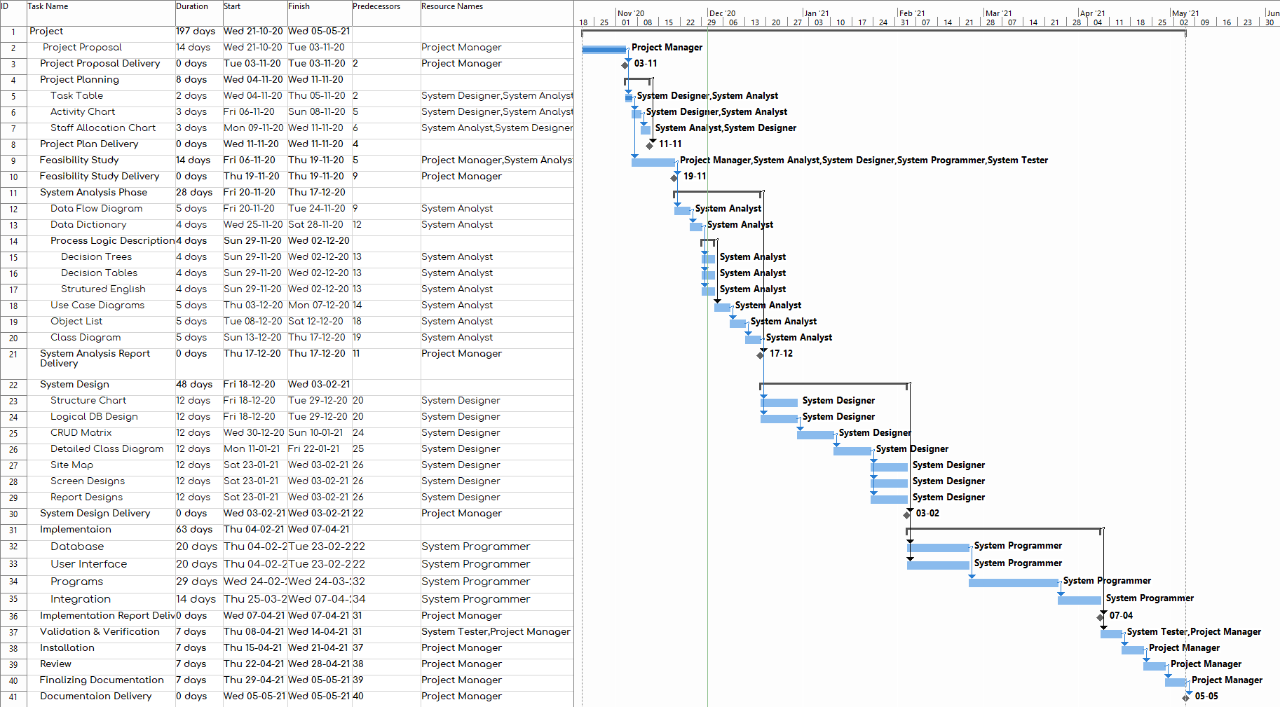

Figure : Gantt chart

## Risk Management

## 2.6.1 Risk Identification & Analysis

**Risk identification Risk analysis**

|  |  |  |  |
| --- | --- | --- | --- |
| Risk Type | Potential indicators | Risk probability | Risk seriousness |
| Technology | Hardware (computer) destroys, late delivery of hardware or support software, many reported technology problems. | Very high  (>75%) | Catastrophic |
| People | Staff disease ,Bringing in new people with incompatible skills and poor staff morale poor relationships on teams member | Moderate  (25-50%) | Tolerable |
| Organization | Lack of finance for the company ,Not to develop a plan for emergency situations that may face the company, lack of action by senior management | Very high  (>75%) | Catastrophic |
| Tools | Shortage of tools and failure to keep pace with modern developments | High  (50-75%) | Serious |
| Requirements | Customer complaints and a lot of requests that are difficult to fulfill | Low  (<10%) | Tolerable |
| Estimation | Failure to meet agreed schedule , failure to clear reported defects | High  (50-75%) | Serious |

Table : Risk Identification & Risk Analysis

## 2.6.2 Risk Planning

|  |  |
| --- | --- |
| Risks | Strategy |
| Hardware (computer) destroys, late delivery of hardware or support software, many reported technology problems. | Use another hardware, which has backup.  And use GitHub to recover codes |
| Staff disease ,Bringing in new people with incompatible skills and poor staff morale poor relationships on teams member | Reorganize team so that there is more overlap of Work and people there for understand each Other work.  Provide new employees with training to be sufficiently experience.  Give enthusiasm for employees by bonus. |
| Lack of finance for the company ,Not to develop a plan for emergency situations that may face the company, lack of action by senior management | Prepare document for manager showing How the project is making a very Contribution to the goals of the business. |
| Shortage of tools and failure to keep pace with modern development | Use alternative tools as defined in the contingency plan |
| Customer complaints and a lot of requests that are difficult to fulfill | Derive traceability information to issue requirements, change impact and maximize information hiding in the design. |
| Failure to meet agreed schedule , failure to clear reported defects | Inspect contingency plan, and follow as specified in order to overcome the failure. |

Table : Risk Analysis

# Chapter Three

# (Feasibility Study)

# 3.1 Introduction

Feasibility Study is an analytical tool used during project planning process, shows how a business would operate under an explicitly stated set of assumptions. It is also an analysis that takes into consideration the project’s factors, which include; economic, technical, legal and financial factors that determine the success rate of the project. Feasibility study lays down all the advantages and disadvantages of carrying out a project, to eliminate the need of investing time, money, efforts and resources into a project that will ultimately fail. Also, it provides crucial information that is the risk management and analysis. Moreover, it provides historical background of the project to help aide technical development and project implementation.

# 3.2 Feasibility Study

## 3.2.1 Feasibility study types:

1. Technical Feasibility [12]

This assessment focuses on the technical resources available to the organization. It helps organizations determine whether the technical resources meet capacity and whether the technical team is capable of converting the ideas into working systems. Technical feasibility also involves the evaluation of the hardware, software, and other technical requirements of the proposed system. As an exaggerated example, an organization wouldn’t want to try to put Star Trek’s transporters in their building—currently, this project is not technically feasible.

2. Economic Feasibility [13]

This assessment typically involves a cost/ benefits analysis of the project, helping organizations determine the viability, cost, and benefits associated with a project before financial resources are allocated. It also serves as an independent project assessment and enhances project credibility—helping decision-makers determine the positive economic benefits to the organization that the proposed project will provide.

3. Operational Feasibility [14]

This assessment involves undertaking a study to analyze and determine whether—and how well—the organization’s needs can be met by completing the project.

Operational feasibility studies also examine how a project plan satisfies the requirements identified in the requirements analysis phase of system development.

## 3.2.2 Importance of Feasibility Study

The importance of a feasibility study is based on organizational desire to “get it right” before committing resources, time, or budget. A feasibility study might uncover new ideas that could completely change a project’s scope. It’s best to make these determinations in advance, rather than to jump in and to learn that the project won’t work. Conducting a feasibility study is always beneficial to the project as it gives you and other stakeholders a clear picture of the proposed project.

Below are some key benefits of conducting a feasibility study:

* Improves project teams’ focus
* Identifies new opportunities
* Provides valuable information for a “go/no-go” decision
* Narrows the business alternatives
* Identifies a valid reason to undertake the project
* Enhances the success rate by evaluating multiple parameters
* Aids decision-making on the project
* Identifies reasons not to proceed

## 3.2.3 Technical feasibility

* **Hardware:**

**For Development**

* + **Personal Computer**
    - 3.8 – 4.2 GHz Processor
    - 16GB Ram
  + **Host Server**

**Minimum Requirements for Users**

* + **Laptops, Personal Computer, Tablets and Mobile Phones**
    - Internet Access
* **Software:**

**For Development**

* + MS project
  + MS office
  + Visual studio code
  + Dreamweaver
  + WAMP Server
* **Technical language**
* HTML
* JavaScript
* PHP
* CSS

## 3.2.4 Project Financial Costs [15]

|  |  |  |  |  |
| --- | --- | --- | --- | --- |
| Costs |  |  |  |  |
| 1- Personnel | **No.** | **Rate LE/Day** | **Duration in Days** | **Total Costs** |
| Project Manager | 1 | 1800 | 51 | 91800 |
| System Analyst | 1 | 1600 | 28 | 44800 |
| System Designer | 1 | 1200 | 48 | 57600 |
| System Programmer | 2 | 1000 | 63 | 126000 |
| System Tester | 2 | 400 | 7 | 5600 |
| Total Personnel Costs |  |  |  | 325800 |
| 2- Used Hardware in Development | **no** | **cost(le)/pc(laptop)** | | **total cost** |
| printer | 1 | 300 |  | 300 |
| Computers | 5 | 1500 |  | 7500 |
| Total Hardware Costs |  |  |  | 7800 |
| 3- Used Software Development |  |  |  | cost per software(le) |
| MS Project |  |  |  | 800 |
| MS Office |  |  |  | 2000 |
| MySQL DBMS |  |  |  | 0 |
| PHP |  |  |  | 0 |
| JavaScript |  |  |  | 0 |
| HTML |  |  |  | 2800 |
| Total Software Costs |  |  |  | 2800 |
| 4- Overhead Costs | no of month | cost (le) month | | total cost |
| electricity | 7 | 500 |  | 3500 |
| telephone calls | 7 | 150 |  | 1050 |
| Internet Connection | 7 | 500 |  | 3500 |
| water | 7 | 200 |  | 1400 |
| Other Overhead Costs | 7 | 100 |  | 700 |
| Total Overhead Costs |  |  |  | 10150 |
| Total Project Cost |  |  |  | 338750 |
| Target Profit |  |  |  | 200000 |
| Software selling price |  |  |  | 538750 |

Table : Financial Costs

## 3.2.5 Revenue model Definition[16]

A revenue model is a framework for determining how a business will earn revenue. Revenue models map out the value proposition of a business, how to price the value, and how customers will pay for it.

**Types of Revenue Model:**

* Advertising revenue model
* Subscription revenue model
* Transaction fee revenue model
* Sales revenue model
* Affiliate revenue model

**For our web application we choose**

* Subscription revenue model
* Online adds

**Subscription Revenue Model:**

The subscription based business model is a business model that charges customers a recurring fee — typically monthly or yearly — to access a product or service.

* In our web application the charities will pay fee yearly for subscription
* And the cost of subscription per year = 4000 L.E

## 3.2.6 Payback Period

The payback period refers to the amount of time it takes to recover the cost of an investment. Simply put, the payback period is the length of time an investment reaches a break-even point.

**Based on this graph the cumulative costs and cumulative benefits intersected at point which is the payback period between year2 and year3.[17]**

|  |  |  |  |  |
| --- | --- | --- | --- | --- |
| Years | Costs | Cumulative Costs | Benefits | Cumulative Benefits |
| 0 | 338,750 | 338,750 | 0 | 0 |
| 1 | 150,600 | 489,350 | 230,625 | 230,625 |
| 2 | 18,000 | 507,350 | 536,046 | 766,671 |
| 3 | 16,000 | 523,350 | 670,057 | 1,436,728 |
| 4 | 12,000 | 535,350 | 790,050 | 2,226,778 |

Table : Payback Period

## 3.2.7 Cash Flow[18]

The following cash flow will show the project expected revenues and expenses for 2 years

Based on the revenue model that we will work with it

* Subscription revenue model
* Online Advertising revenue model

For subscription revenue model: in order for each charity to join the system, they have to pay the 4000 L.E yearly subscription fee

For advertising revenue model : in order to show online add on the home page for the website we expected to have 3 adds each add will generate 0.16 L.E per click and 0.10 per view .

To expect the 2 years based on this information the change for each quarter will increase by 25%

For example on **quarter 1**

8 charities * 4000 = 32000 L.E

And expected revenue from online adds almost 6000 L.E

The total revenue =40000 L.E

So following with 25% increasing

**Quarter 2 expected** to be 50000 L.E

|  |  |  |  |  |  |
| --- | --- | --- | --- | --- | --- |
| YEAR ONE | | | | | |
|  | **Q1** | **Q2** | **Q3** | **Q4** | **Total Year 1** |
| Revenue | EGP 40,000 | EGP 50,000 | EGP 62,500 | EGP 78,125 | EGP 230,625 |
| Costs | | | | | |
| Total Personnel Cost | EGP 325,800 | EGP 6,000 | EGP 6,000 | EGP 4,000 | EGP 341,800 |
| Total Hardware Cost | EGP 7,800 | EGP 7,500 | EGP 0 | EGP 0 | EGP 15,300 |
| Total Software Costs | EGP 2,800 | EGP 2,800 | EGP 0 | EGP 0 | EGP 5,600 |
| Total Overhead Costs | EGP 1,450 | EGP 1,450 | EGP 1,450 | EGP 1,450 | EGP 5,800 |
| Total Costs | **EGP 337,850** | **EGP 17,750** | **EGP 7,450** | **EGP 5,450** | **EGP 368,500** |
|  | | | | | |
| Cash Flow | -EGP 297,850 | EGP 32,250 | EGP 55,050 | EGP 72,675 | -EGP 137,875 |
| Cumulative Cash Flow | -EGP 162,050 | -EGP 129,800 | -EGP 74,750 | -EGP 2,075 | -EGP 139,950 |

Table : Cash Flow (Year One)

|  |  |  |  |  |  |
| --- | --- | --- | --- | --- | --- |
| YEAR TWO | | | | | |
|  | **Q1** | **Q2** | **Q3** | **Q4** | **Total Year 2** |
| Revenue | EGP 97,656 | EGP 122,070 | EGP 152,587 | EGP 190,733 | EGP 563,046 |
| Costs | | | | | |
| Total Personnel Cost | EGP 4,000 | EGP 2,000 | EGP 2,000 | EGP 1,000 | EGP 9,000 |
| Total Hardware Cost | EGP 0 | EGP 0 | EGP 0 | EGP 0 | EGP 0 |
| Total Software Costs | EGP 0 | EGP 0 | EGP 0 | EGP 0 | EGP 0 |
| Total Overhead Costs | EGP 1,450 | EGP 1,450 | EGP 1,450 | EGP 1,450 | EGP 5,800 |
| Total Costs | **EGP 5,450** | **EGP 3,450** | **EGP 3,450** | **EGP 2,450** | **EGP 14,800** |
|  | | | | | |
| Cash Flow | EGP 92,206 | EGP 118,620 | EGP 149,137 | EGP 188,283 | EGP 548,246 |
| Cumulative Cash Flow | -EGP 69,769 | EGP 48,851 | EGP 197,988 | EGP 386,271 | EGP 934,517 |

Table : Cash Flow (Year Two)

## 3.2.8 Operational Feasibility

In this part of feasibility study, we are going to focus on the operational part in our project

* Such as the users and there features
* The user interface
* How we can attract the users
* How can we help & satisfy users
* Users

Our users that people who feel responsibility for the community and people who needs help , the target people in range 18-55 years old that can manage with website .

User features:

1. Donating categories
2. Confirmation SMS/E-Mail
3. Rating and Reviews
4. Setting a Reminder
5. Integrating social media
6. Historical Data
7. Finding a wide range

## 3.2.9 User interface and attraction

Our Website will provide a simple and effective user interface to helps user to feel more comfy with it by just a simple clicks, this will save time and efforts

This will attract user to easily donate through our website and increase the rating of donations

Because all people now spend most of their times online

In addition to the SMS and reminder that people will get once they login to website

Will help them not to forget to make their donations

So people will find easy way to donate many categories with many option.

## 3.2.10 Support System

Adding online support system 24 hour in order to help users if they face any problem with website

And we will provide a simple intro for user to teach them how to deal with the website

# Chapter Four

# (System Analysis)

# 4.1 Introduction

In business, System Analysis and Design refers to the process of examining a business situation with the intent of improving it through better procedures and methods. System analysis and design relates to shaping organizations, improving performance and achieving objectives for profitability and growth. The emphasis is on systems in action, the relationships among subsystems and their contribution to meeting a common goal.

Looking at a system and determining how adequately it functions, the changes to be made and the quality of the output are parts of system analysis. Organizations are complex systems that consist of interrelated and interlocking subsystems. Changes in one part of the system have both anticipated and unanticipated consequences in other parts of the system. The systems approval is a way of thinking about the analysis and design of computer based applications. It provides a framework for visualizing the organizational and environmental factors that operate on a system. When a computer is introduced into an organization, various functions’ and dysfunction’s operate on the user as well as on the organization. Among the positive consequences are improved performance and a feeling of achievement with quality information. Among the unanticipated consequences might be a possible threat to employees’ job, a decreased morale of personnel due to back of involvement and a feeling of intimidation by users due to computer illiteracy. The analyst’s role is to remove such fears and make the system a success. System analysis and design focus on systems, processes and technology.

# 4.1.1 Comparison between Structured approach and Object-oriented approach[19]

Structured analysis is method of development that allows and gives permission to the analyst to understand and know about the system and all of its activities in a logical way. It is simply a graphic that is used to specify the presentation of the application.

Object-Oriented Analysis (OOA) is technical approach generally used for analyzing and application designing, system designing, or even business designing just by applying object-oriented programming even with the use of visual modeling throughout the process of development to just simply guide the stakeholder communication and quality of the product. It is actually a process of discovery where a team of development understands and models all the requirements of the system.

# 4.2 Data Flow Diagram[20]

A picture is worth a thousand words. A Data Flow Diagram (DFD) is a traditional way to visualize the information flows within a system. A neat and clear DFD can depict a good amount of the system requirements graphically. It can be manual, automated, or a combination of both.

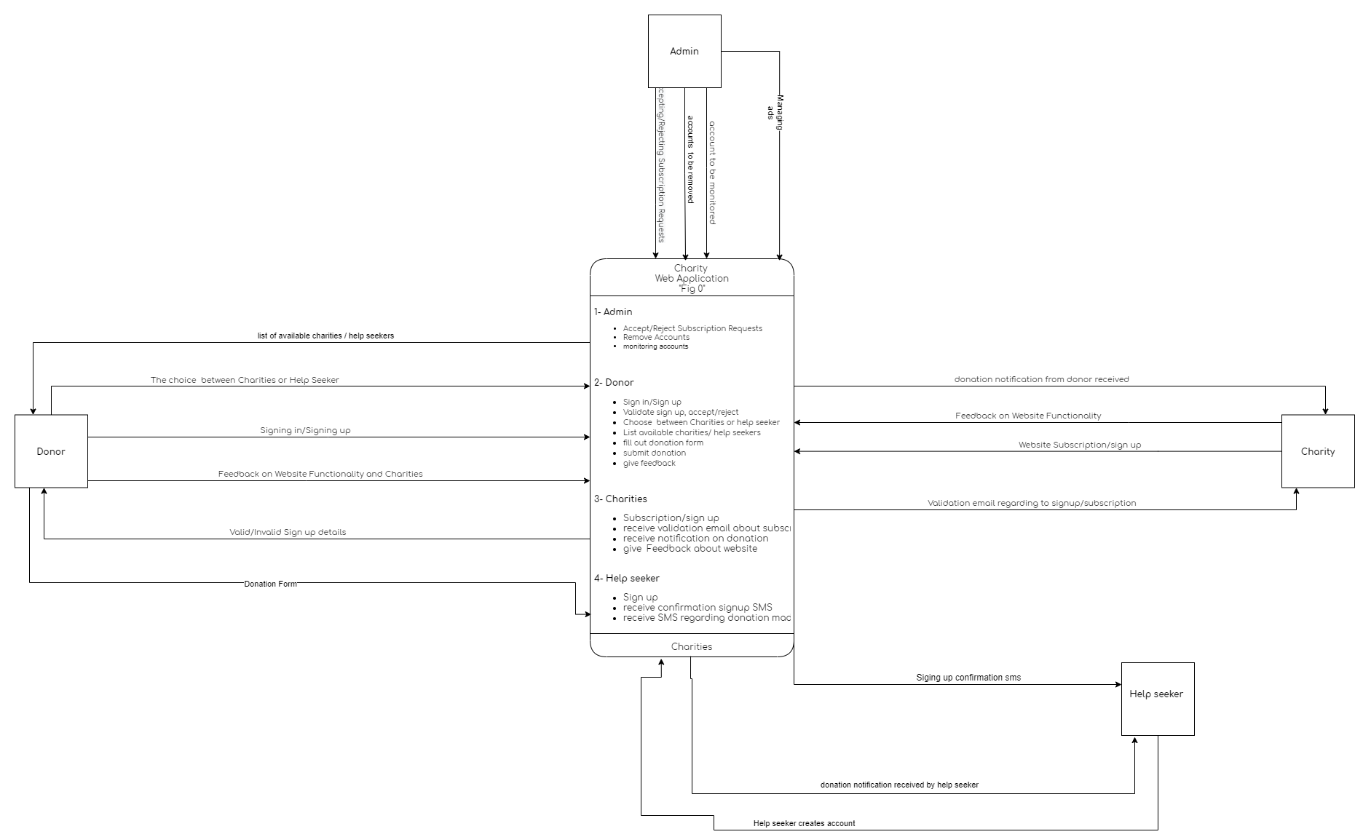

Figure : Data Flow Diagram

# 4.3 Level Zero Data Flow Diagram[21]

A level 0 data flow diagram (DFD), also known as a context diagram, shows a data system as a whole and emphasizes the way it interacts with external entities. This DFD level 0 example shows how such a system might function within a typical retail business.

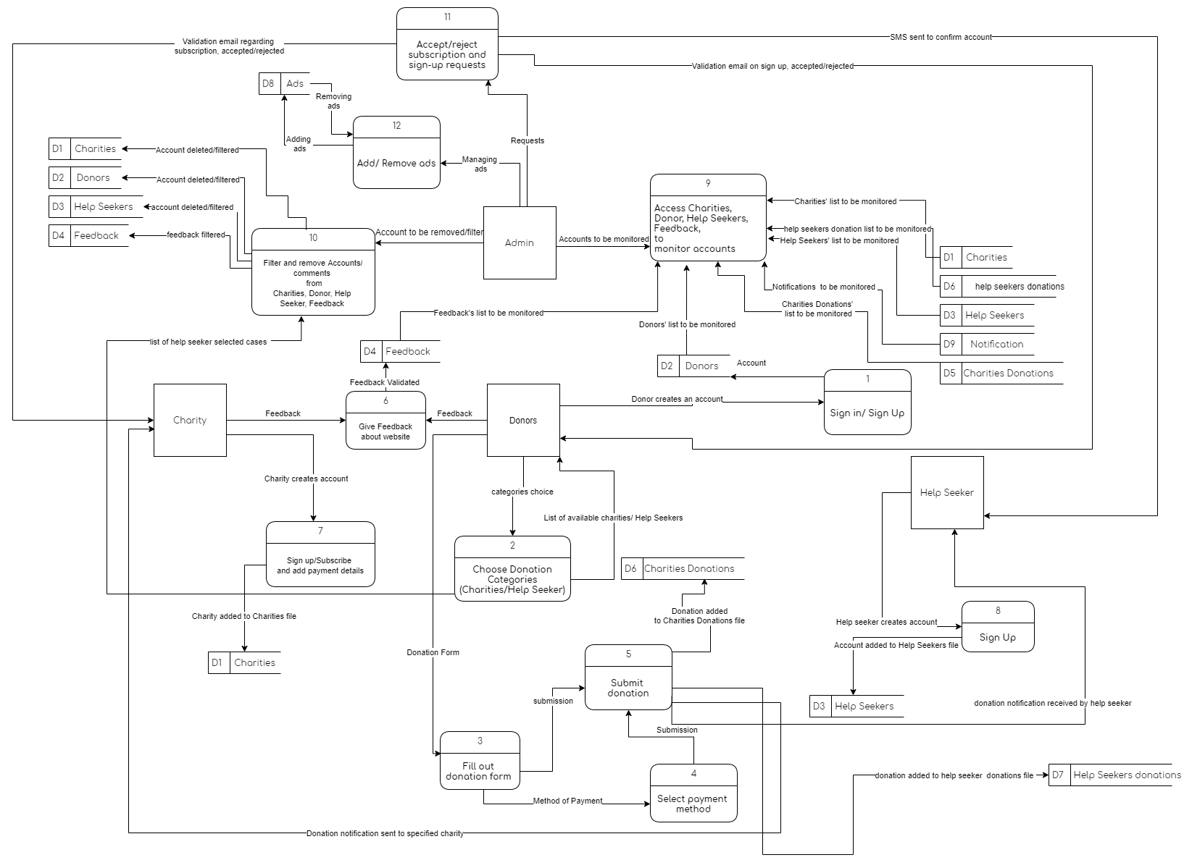

Figure : Level Zero Diagram

# 4.4 Process Logic Description

Process logic is best represented through structured English, decision tables, decision trees or specified formulas or algorithms and is used to communicate engineering requirements and procedures to businesses involved in the creation of a process.

## 4.4.1 Structured English[22]

PID1:

Process name: “sign in / sign up”

Begin

Read donor choice sign in/sign up

If donor sign up then

Begin

Read donor information

Create new donor information record in donors file

End

ELSEIF donor sign in THEN

BEGIN

Read donor name and password

Validate UN AND PW

If valid UN and PW then display home page

ELSE display invalid UN OR PW

End

ENDIF

END

PID: 2

Process name: “choose donation categories (charities/help seeker)”

BEGIN

Read donor categories choice

IF (donor choice==option A) then

BEGIN

Display list of Available charities

Select the charity

ELSE Display available help seekers cases

END

ENDIF

END

PID: 3

Process name: “fill out donation form”

BEGIN

Read donor donation form

IF (donor choice==option A) then

Begin

Display items donation form

Submit donation form

ELSE

Display method of payment

Submit donation form

END

ENDIF

END

PID: 4

Process name: “select payment method”

BEGIN

Read donation form

BEGIN

If (donor choice == option A) THEN

Read visa information of donor

Else

Donate cash

END

ENDIF

END

PID: 5

Process name: “Submit donation”

BEGIN

Read donation form

BEGIN

IF donor submit donation

THEN

Add donation to charities donations file

Send notification to the charity

ELSE Add donation to help seekers donations file

END

ENDIF

END

PID: 6

Process name: “give feedback about website”

BEGIN

Read donor and charity feedback

Begin

If feedback validated

Then

Create new feedback record to feedback file

END

ENDIF

END

PID: 7

Process name: “sign up/subscribe and add payment details”

Begin

Read charity choice subscribe/sign in

If charity subscribe then

Begin

Read charity information

Create new charity information record in charities file

End

ELSEIF charity sign up THEN

BEGIN

Read charity name and password

Validate UN AND PW

If valid UN and PW then display home page

ELSE display invalid UN OR PW

End

ENDIF

END

PID: 8

Process name: “Sign up”

BEGIN

Read help seeker’s decision to sign up

If help seeker sign up then

Begin

Read help seeker information

Create new help seeker information record in help seekers file

END

ENDIF

END

**PID: 9**

**Process name: “Access Charities, Donor, Help Seekers, Feedback, transactions to monitor accounts”**

**BEGIN**

**Read information in all data stores**

**BEGIN**

**IF**

PID: 10

Process name: “Filter and remove Accounts/ transactions /comments from Charities, Donor, Help Seeker, Feedback and Transactions”

BEGIN  
Read information from charities, donors, help seekers, feedback and transactions files

If admin had to delete an account THEN

Begin

Specified account deleted from intended file

End

ELSE

Specified account remains in intended file

ENDIF

END

PID: 11

Process name: “Accept/reject subscription and sign-up requests”

BEGIN

Read requests from admin

BEGIN

IF (request == option A) THEN

Send conformation email to donor

ELSE

Send invalid information email to donor

END

ELSEIF (request == option B) THEN

BEGIN

Send conformation email to charity

ELSE

Send invalid information email to charity

END

ELSEIF (request == option C) THEN

BEGIN

Send confirmation SMS to help seeker

ELSE

Send rejection SMS to help seeker

END

ENDIF

END

PID: 12

Process name: “Add/Remove ads”

BEGIN

Read online ad requests

BEGIN

IF ad is approved THEN

Add ad to ads file

ELSE

Disregard ad request

END

ENDIF

END

# 4.5 Data Dictionary

A data dictionary is a file or a set of files that includes a database's metadata. The data dictionary hold records about other objects in the database, such as data ownership, data relationships to other objects, and other data. The data dictionary is an essential component of any relational database.

The following shows the Data Flow, Data Elements, Data Store, Data External Entries and Data Process.

4.5.1 Data elements[23]

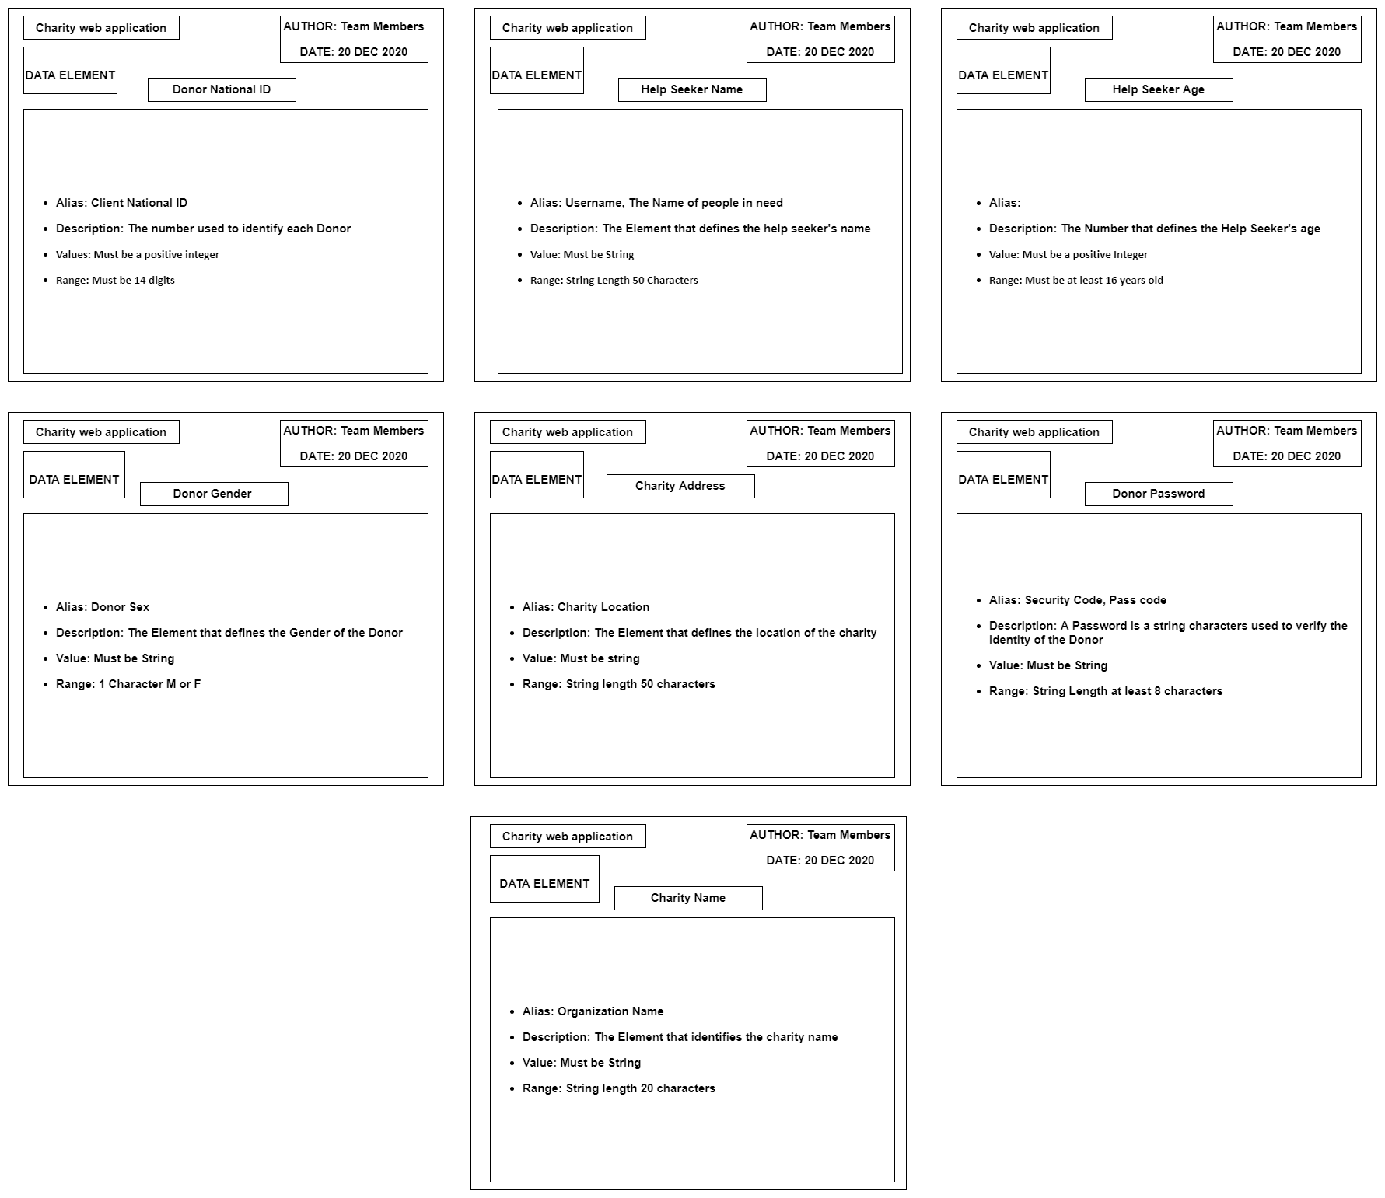

4.5.2 Data flows

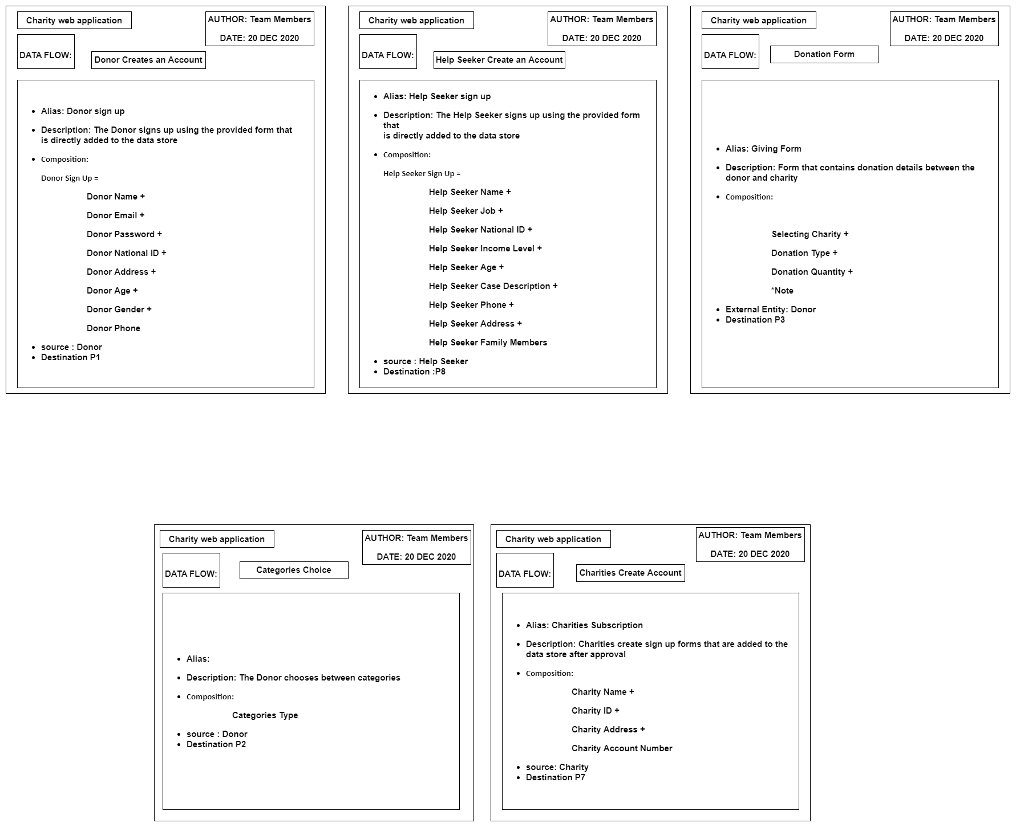

4.5.3 Data Stores

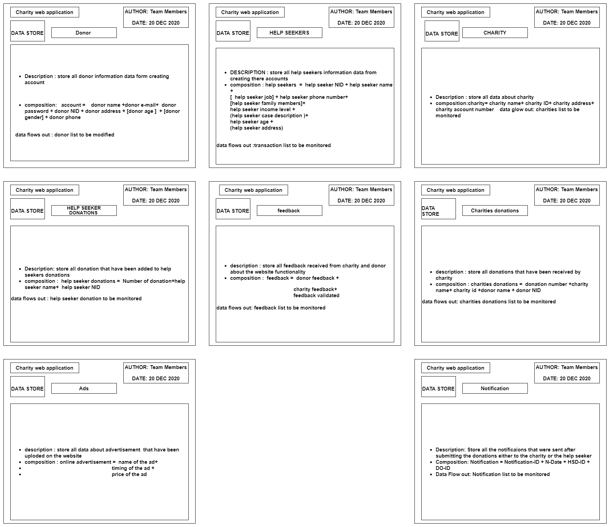

4.5.4 Data processes

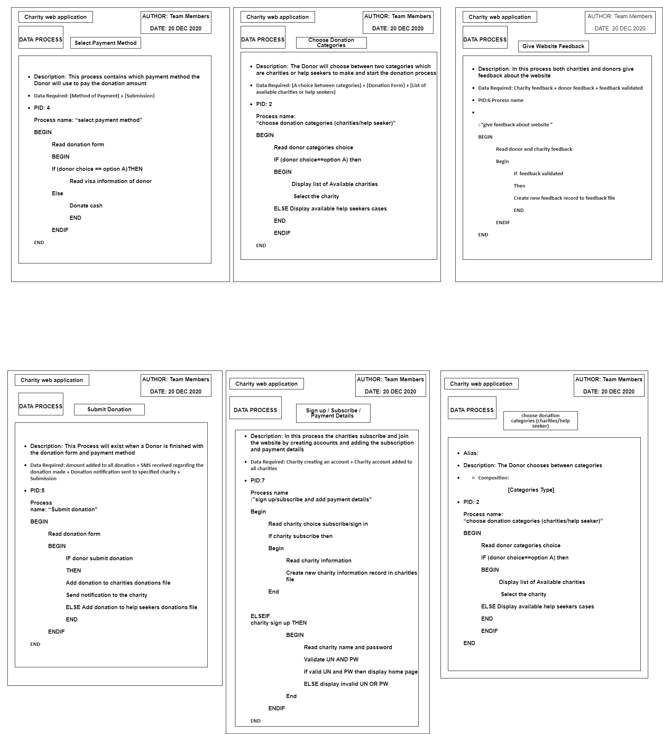

4.5.5 External entities

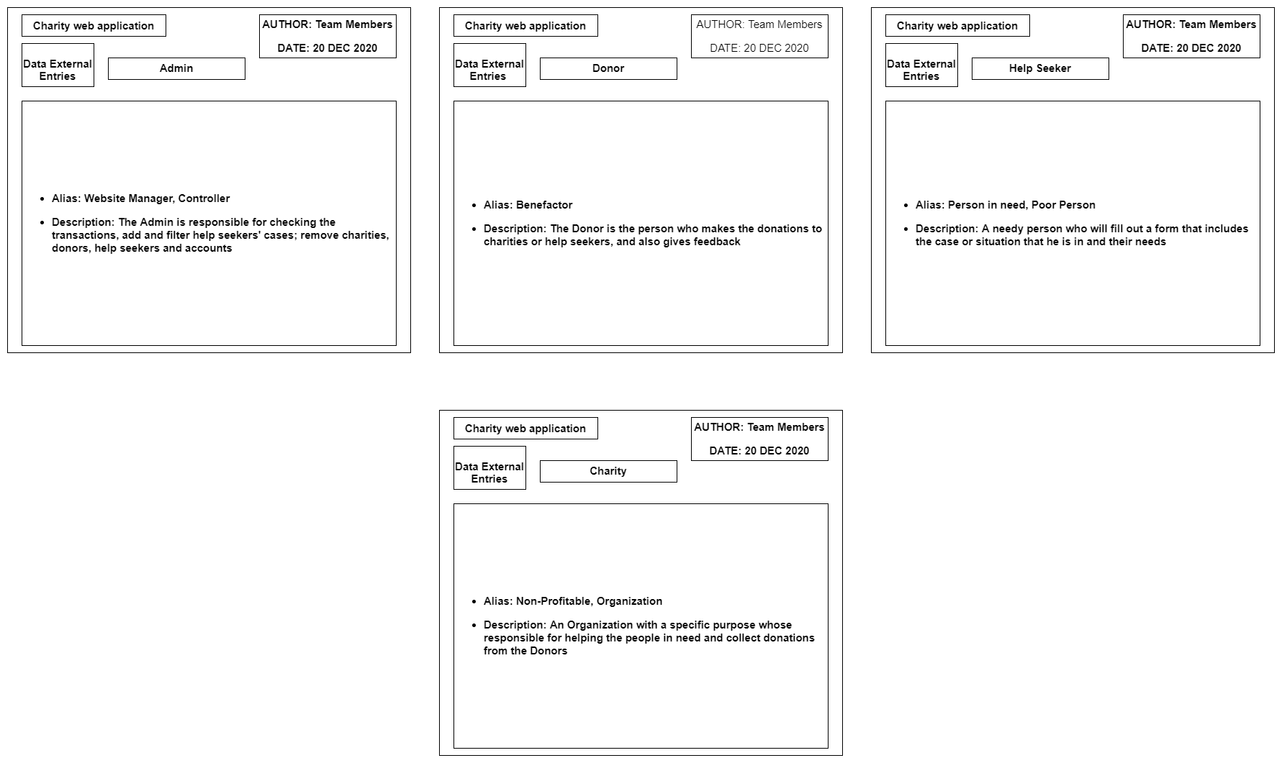

# 4.6 Use Case Diagram[24]

A use case diagram at its simplest is a representation of a user's interaction with the system that shows the relationship between the user and the different use cases in which the user is involved. A use case diagram can identify the different types of users of a system and the different use cases and will often be accompanied by other types of diagrams as well. The use cases are represented by either circles or ellipses.

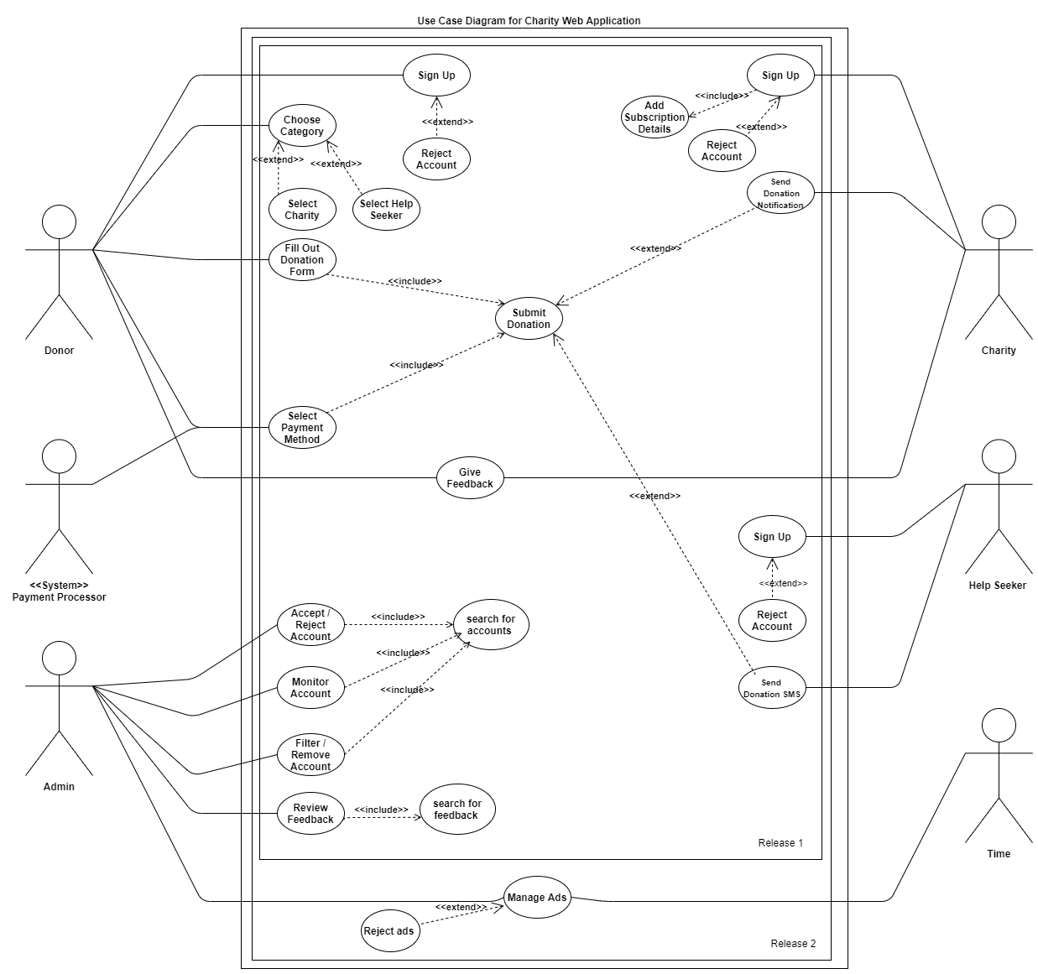

Figure : Use Case Diagram

## 4.6.1 UML Use Case Description

|  |
| --- |
| Charity web application  12 Jan 2021 |
| Submit donation |
| Use case /process ID : US5 priority : High |
| Actors: Donor |
| Goal : to submit the donor donation for desired destination |
| Preconditions:   1. Donor have an account 2. Donor must fill out the donation form |
| Flow of Events :   1. 1-donor sign in/sign up 2. Select the donation categories (charity /help seeker) 3. Fill out the donation form with all details 4. Select the payment method if the donation type = money 5. Submit the donation |
| Post-conditions:   1. The Charity or help seeker receive a donation notification 2. The donation have been added in each of charity donation or help seeker donation data store |
| Alternative flow 1:   1. Submitting donation have been failed because of load on the website or technical issue |
| Alternative flow 1 post-condition :   1. Donor connected directly with the help seeker or charity phone number 2. Or try to donate again after a while |

Table : Use Case Description

**Chapter five**

# (System Design)

# 5.1 introduction

Systems design is the process of defining elements of a system like modules, architecture, components and their interfaces and data for a system based on the specified requirements. It is the process of defining, developing and designing systems which satisfies the specific needs and requirements of a business or organization

Having a Design System in place acts a savior. It closes the gap between the designers and UI engineers who work on multiple products and often re-create or duplicate work done by other teams. Designer and Developer communication is important to improve project workflow, as it helps save time and money. It can also improve consistency across platforms, build more-intuitive products, and allow designers and engineers to focus on addressing bigger problems.

# 5.2 Entity Relationship Diagram[25]

An Entity Relationship Diagram (ERD) is a snapshot of data structures. An Entity Relationship Diagram shows entities (tables) in a database and relationships between tables within that database.

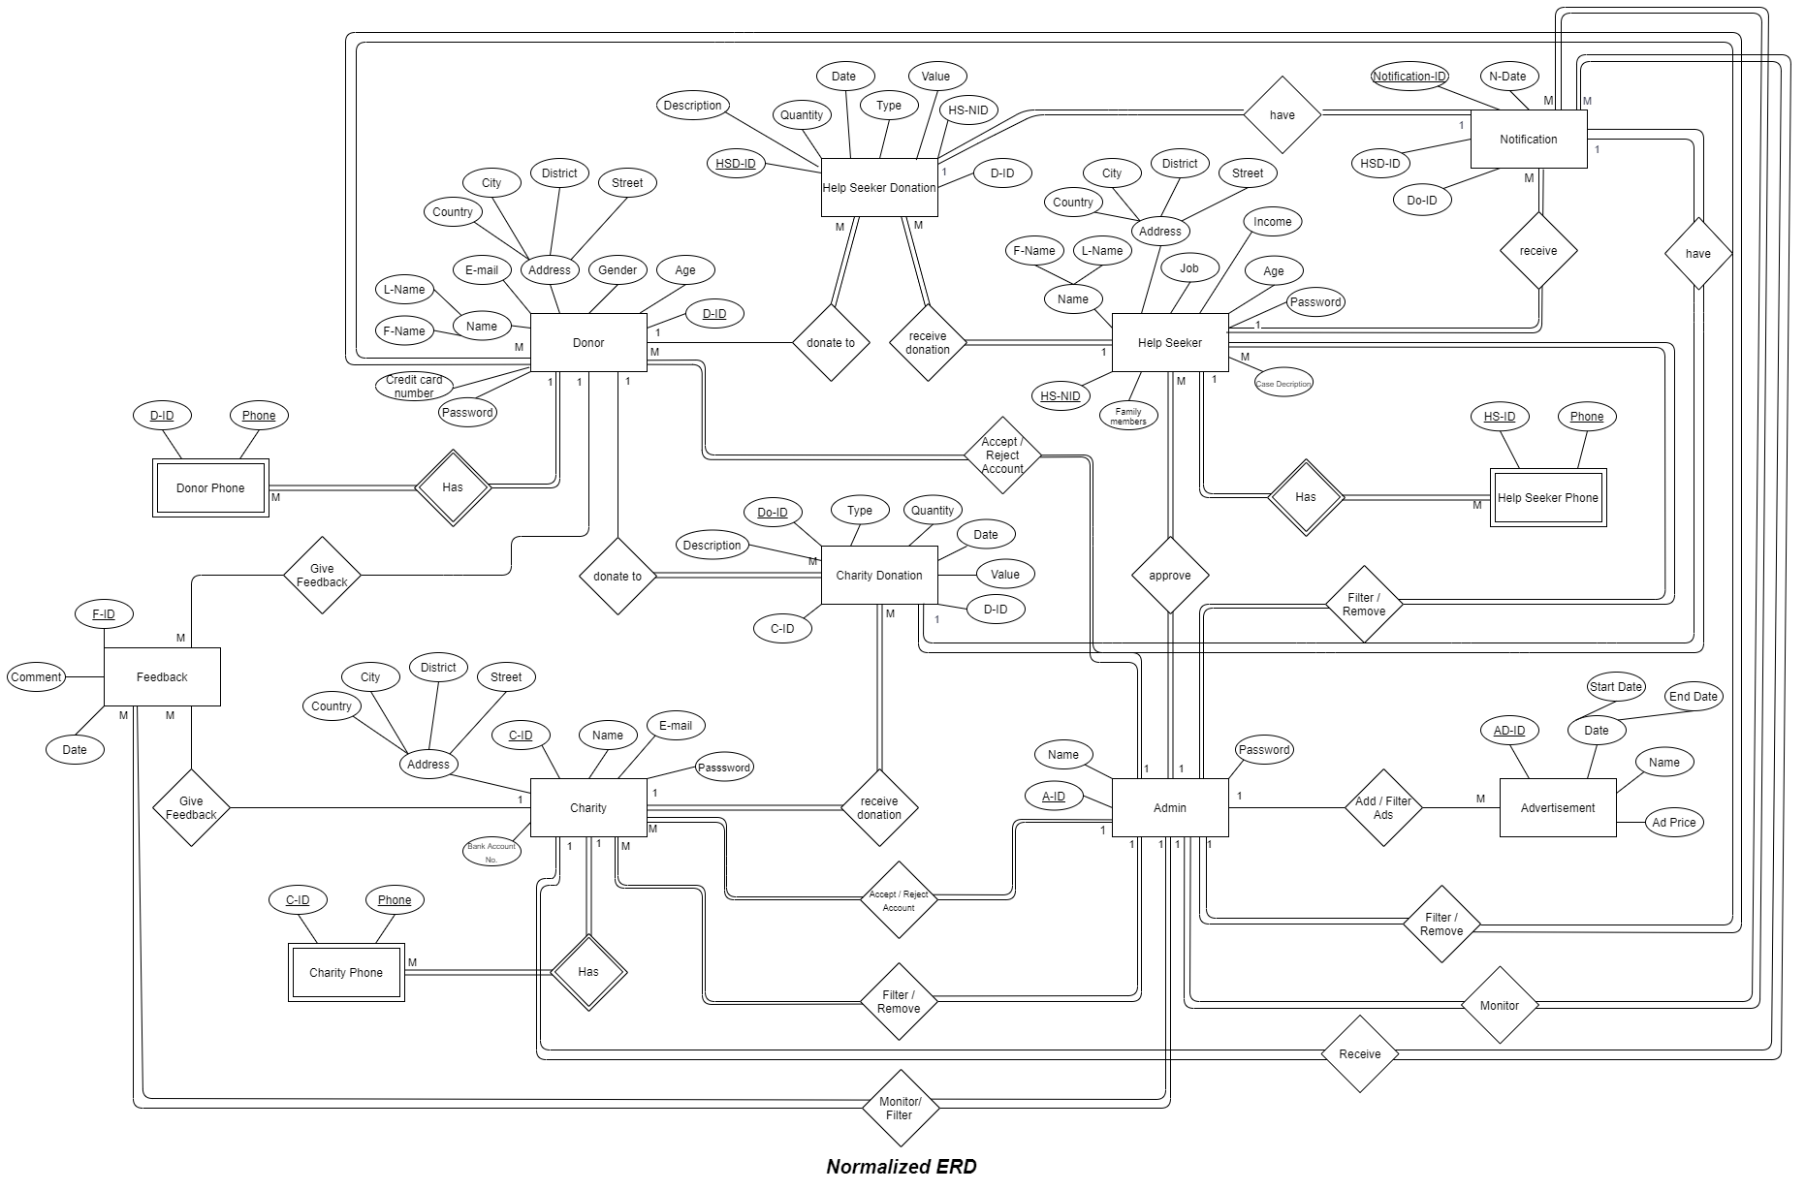

Figure : Entity Relationship Diagram

# 5.3 Class diagram[26]

The **UML** Class diagram is a graphical notation used to construct and visualize object oriented systems. A class diagram in the Unified Modeling Language (UML) is a type of static structure diagram that describes the structure of a system by showing the systems:

* classes,
* their attributes,
* operations (or methods),
* And the relationships among objects.

According to MVC architecture (model, view, controller)

-Business entity model **(classes)** list:

* Help seeker
* Charity
* Admin
* Donor

-Interface and user interface **(view)** classes such as:

* Feedback
* Advertisement
* Donation Form
* Notifications

-Business logic **(controller)** classes such as:

* Charity donation
* Help seeker donation

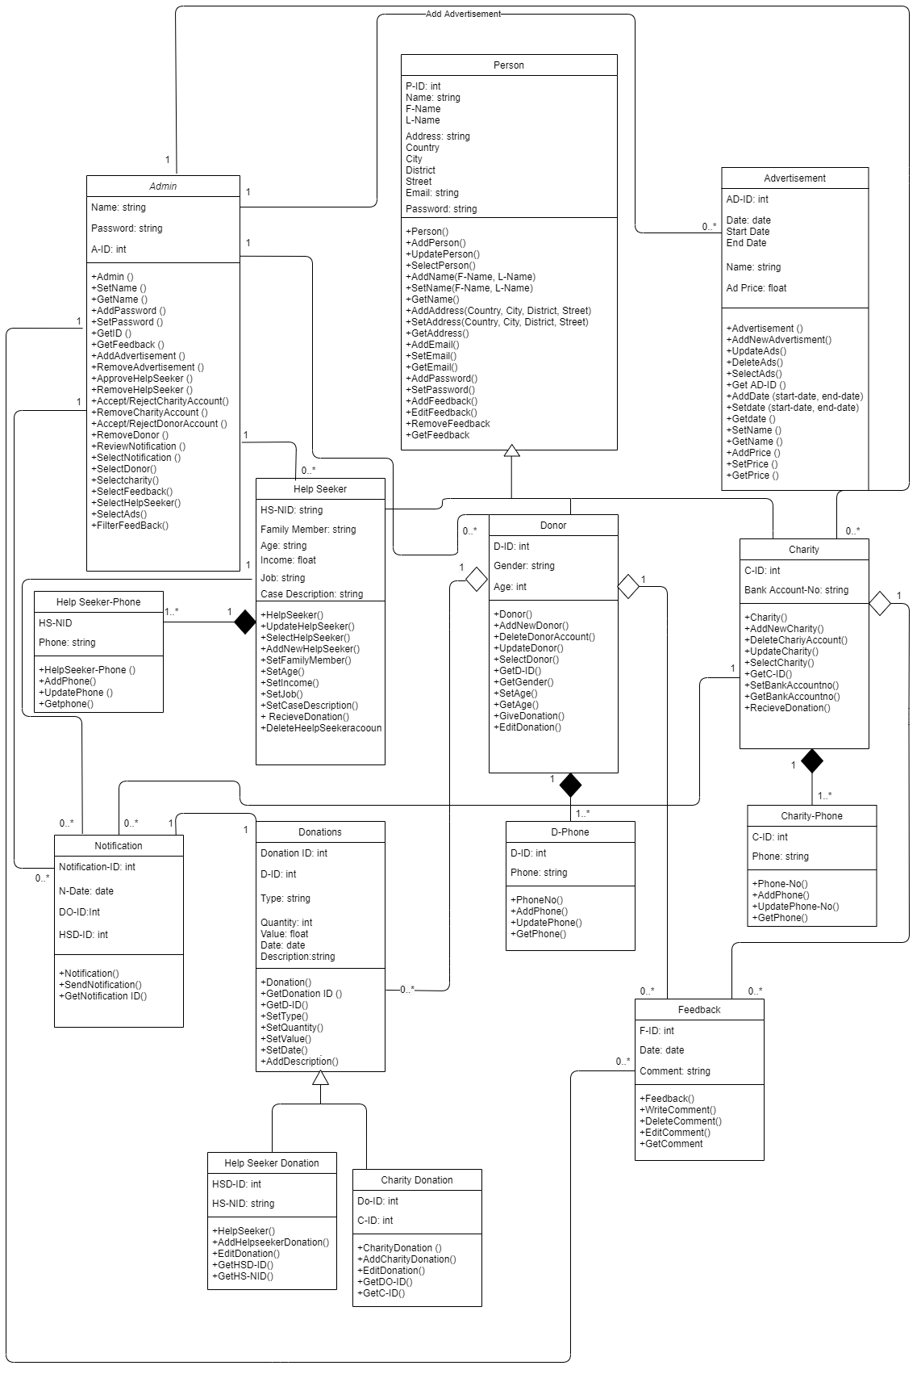

Figure : Class Diagram

# Summary

To summarize the above content of the project, the Charity Web Application is designed in order to fulfill the lacking means of providing help to the Egyptians who are in need of help. With the ever-developing computer systems, programs and different programming languages, the Charity Web Application will allow all Egyptians to make donations to their intended charities or directly to a Help Seeker whom is seeking to acquire help from the vast generosity of the Egyptian community.

After carrying out all the required studies that will enable the implementation of the Charity Web Application, it has been determined that the project is applicable for real life implementation and its foreseeing benefits shall support the Egyptian community greatly. Firstly, this is presented through the feasibility studies that showed the breakdown of each of the technical, economic and operational feasibilities. Those studies lead to the projection of the expected total costs for the first year to equal EGP 368500 and total revenues accumulated shows the expected Payback period to be within two to three years, keeping in mind the revenues are solely from ads displayed on the website as this is a charity web application.

Secondly, with the aid of multiple drawings, which include the Data Flow Diagram (DFD), the Entity Relationship Diagram (ERD) Class Diagram and Use Case Diagram, it was possible to represent the functions of the system and how each function is related to each other. Also, the entities that will be using the system which are the donors, charities, help seekers and admin, as well as the overall mean of how the system will be implemented.

Overall, the above describes the steps needed to implement the Charity Web Application that will be used for the benefit of the less fortunate. Proceeding from the steps of implementation will be the actual implementation of the system, which will be presented the remaining half of the project. The implementation phase will include the physical application of the acquired information throughout this document, combining the future gathered resources that will allow the implementation of the system, to ensure availability of the Charity Web Application for all donors who are willing to provide more to the Egyptian community.

# References

1. <https://crzaman.blogspot.com/2016/12/php-introduction-to-beginners.html> Retrieved 23rd October 2020.
2. <https://en.wikipedia.org/wiki/MySQL> Retrieved 23rd October 2020.
3. <https://www.hostinger.com/tutorials/what-is-html> Retrieved 23rd October 2020.
4. <https://developer.mozilla.org/en-US/docs/Learn/JavaScript/First_steps/What_is_JavaScript> Retrieved 23rd October 2020.
5. <https://www.tutorialspoint.com/css/what_is_css.htm> Retrieved 23rd October 2020.
6. <https://www.projectsmart.co.uk/introduction-to-microsoft-project.php> Retrieved 23rd October 2020.
7. <https://www.hostinger.com/tutorials/what-is-wamp> Retrieved 23rd October 2020.
8. <https://www.scnsoft.com/blog/software-development-models> Retrieved 4th November 2020.
9. <https://www.nibusinessinfo.co.uk/content/advantages-project-management> Retrieved 6th November 2020.
10. <https://www.projectmanager.com/blog/project-management-techniques-for-every-pm> Retrieved 7th November 2020.
11. <https://mopinion.com/top-20-best-project-management-software-an-overview/> Retrieved 7th November 2020.
12. <https://www.sciencedirect.com/topics/computer-science/technical-feasibility> Retrieved 14th November 2020.
13. <https://www.sciencedirect.com/topics/engineering/economic-feasibility> Retrieved 14th November 2020.
14. <https://www.intechopen.com/books/integrated-waste-management-volume-i/economic-and-operational-feasibility-analysis-of-solid-waste-minimization-projects> Retrieved 14th November 2020.
15. A. Sayed, “[Software Project Feasibility Study](https://moodle.fue.edu.eg/course/view.php?id=19368#section-4)”, Graduation Project 1 Lectures, 11th November 2020.
16. A. Sayed, “[Software Project Feasibility Study](https://moodle.fue.edu.eg/course/view.php?id=19368#section-4)”, Graduation Project 1 Lectures, 11th November 2020.
17. A. Sayed, “[Software Project Feasibility Study](https://moodle.fue.edu.eg/course/view.php?id=19368#section-4)”, Graduation Project 1 Lectures, 11th November 2020.
18. A. Sayed, “[Software Project Feasibility Study](https://moodle.fue.edu.eg/course/view.php?id=19368#section-4)”, Graduation Project 1 Lectures, 11th November 2020.
19. <https://www.geeksforgeeks.org/difference-between-structured-and-object-oriented-analysis/> Retrieved 20th November 2020.
20. A. Sayed, “DFD Revision”, Graduation Project 1 Lectures, 18th November 2020.
21. A. Sayed, “DFD Revision”, Graduation Project 1 Lectures, 18th November 2020.
22. A. Sayed, “[Process Modelling Techniques](https://moodle.fue.edu.eg/course/view.php?id=19368#section-6)”, Graduation Project 1 Lectures, 25th November 2020.
23. A. Sayed, “[Data Dictionary](https://moodle.fue.edu.eg/course/view.php?id=19368#section-8)”, Graduation Project 1 Lectures, 9th December 2020.
24. A. Sayed, “[Lecture 10 Video Class Diagram Revision](https://moodle.fue.edu.eg/course/view.php?id=19368#section-10)”, Graduation Project 1 Lectures, 30th December 2020.
25. A. Sayed, “[ERD Revision](https://moodle.fue.edu.eg/course/view.php?id=19368#section-9)”, Graduation Project 1 Lectures, 23rd December 2020.
26. A. Sayed, “[Lecture 10 Video Class Diagram Revision](https://moodle.fue.edu.eg/course/view.php?id=19368#section-10)”, Graduation Project 1 Lectures, 30th December 2020.